PhishGuard
HACK-O-WEEK | WEEK 15-16
Node.js, NPM Packages, HTTP Server, and Express.js

Section 1: Title
Hack-O-Week • Week 15-16 • Node.js, NPM Packages, HTTP Server, and Express.js. This report connects the college assignment to the inspected PhishGuard source code.

Section 2: Objective
Compare the assignment’s Node.js server concepts with PhishGuard’s actual Python/FastAPI backend, then study concise Node and Express demonstrations.

Section 3: Theory
Runtime and modules. Node.js executes JavaScript outside a browser. CommonJS uses require() to load a module and module.exports to expose values. Node built-ins include fs for files, path for path operations, and process for environment and process data.
NPM packages. npm init creates package metadata; npm install adds dependencies. package.json records scripts and package ranges, and a lockfile records resolved versions. The actual frontend defines dev, build, lint, and preview scripts; npm run test is not configured.
HTTP and Express. The built-in http module can create a server and handle request/response objects. Express adds routing and middleware. Middleware processes a request before a route or response; error middleware receives failures. The cycle is request, middleware, route, response.

Section 4: Implementation in PhishGuard
The actual backend is Python 3 with FastAPI and Uvicorn, not Node.js or Express. backend/app/main.py defines GET /api/health and POST /api/analyze; the latter validates a Pydantic request, calls URLAnalyzer, and returns a typed response. CORS middleware allows local development origins. URL analysis parses text only and does not visit the submitted destination. Node built-ins and Express are not used. The frontend is a separate Vite/React Node-based development project with ES modules, not a Node backend.

Section 5: Code Explanation
Actual FastAPI request/response route
Source: backend/app/main.py
Actual application code in Python. FastAPI validates the request model, calls the analyzer, then serializes the response or maps the exception to an HTTP status. The corresponding code is in this week’s companion Code_Examples.md file.
Node built-ins, raw HTTP, and CommonJS
Source: Educational example (not in PhishGuard)
Educational Node.js example. require and module.exports show CommonJS. fs checks for a file; path builds a platform-specific path; process reads PORT; and http creates and starts a request/response server. These modules are not used by the PhishGuard backend. The corresponding code is in this week’s companion Code_Examples.md file.
Express route, middleware, and error handler
Source: Educational example (not in PhishGuard)
Educational Express example. JSON middleware parses request data, the route handles the endpoint, and error middleware converts thrown errors into a response. The corresponding code is in this week’s companion Code_Examples.md file.
Actual frontend package list
Source: frontend/package.json
Actual frontend NPM configuration. npm run dev/build/lint/preview are declared scripts. The Python backend packages in requirements.txt are installed through pip. The corresponding code is in this week’s companion Code_Examples.md file.

Section 6: Working Flow
- A client sends POST /api/analyze with JSON containing url.
- FastAPI parses the request into URLRequest and invokes URLAnalyzer.
- The analyzer validates and parses URL text, applies rules, and returns feature details.
- FastAPI responds with AnalysisResponse, or maps invalid input to 422 and unexpected errors to 500.
- In the educational Express model, middleware parses JSON before a route handles the same request/response pattern.

Section 7: Learning Outcome
PhishGuard demonstrates a Python/FastAPI backend and an NPM-managed React frontend. Node built-ins, CommonJS, HTTP server creation, and Express are assignment examples only.

Section 8: Code Implementation Screenshots
Captured from the project source file open in Visual Studio Code. Captions identify the displayed file. Code examples are in the companion Code_Examples.md file, not in this Word report. Educational examples there are labeled and are not application code.
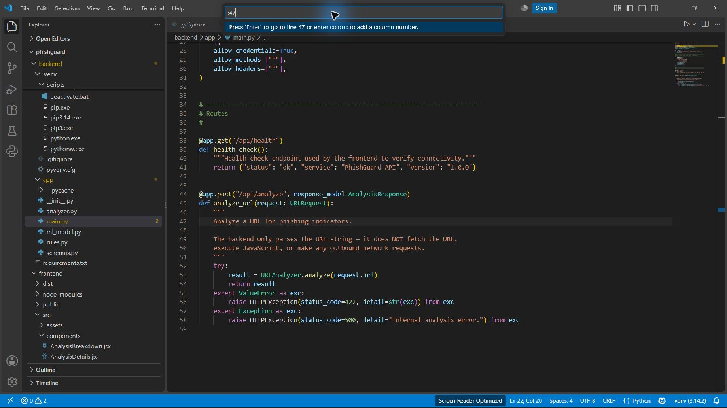
Actual FastAPI route and response handling — backend/app/main.py
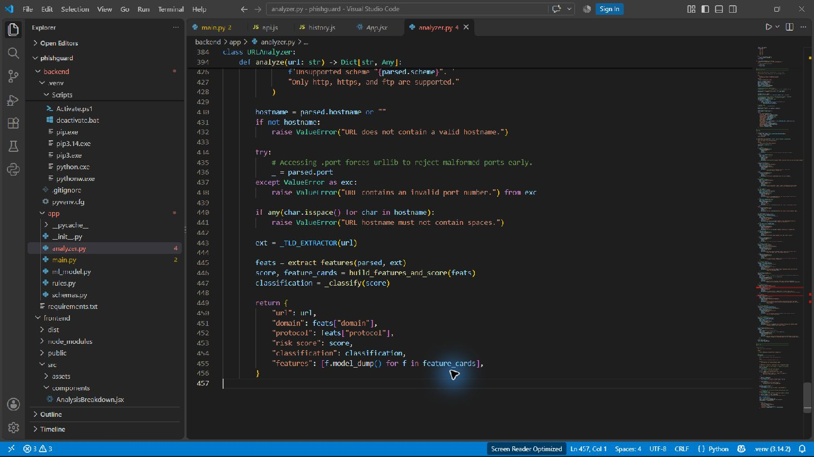
Actual URLAnalyzer validation and analysis — backend/app/analyzer.py

